Mirror Rhyme Couplet

🎯 What is Mirror Rhyme Couplet
# Source: Chatgpt (GPT-4-turbo) at [8/2/2025]
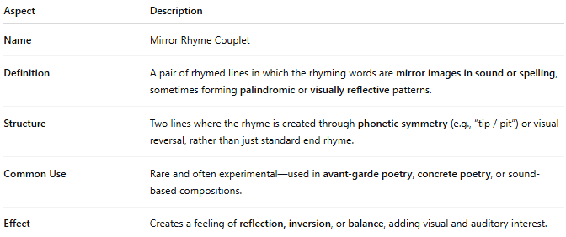
Aspect | Description
Name | Mirror Rhyme Couplet
Definition | A pair of rhymed lines in which the rhyming words are mirror images in sound or spelling, sometimes forming palindromic or visually reflective patterns.
Structure | Two lines where the rhyme is created through phonetic symmetry (e.g., “tip / pit”) or visual reversal, rather than just standard end rhyme.
Common Use | Rare and often experimental—used in avant-garde poetry, concrete poetry, or sound-based compositions.
Effect | Creates a feeling of reflection, inversion, or balance, adding visual and auditory interest.

✅ Example of a Mirror Rhyme Couplet
# Source: Chatgpt (GPT-4-turbo) at [8/2/2025]
She held the stop, and heard the pots arise,
A mirrored clang beneath the evening skies.
- “stop / pots” = mirror rhyme (reverse spelling).

🧠 Key Insight:
# Source: Chatgpt (GPT-4-turbo) at [8/2/2025]
- Not all mirror rhymes are palindromes, but they often rely on letter or sound reversal.
- They work both visually and phonetically, which sets them apart from traditional rhymes.

